User Interface Test

Test performed on the emulator by signing in as anonymous user.

1. App start-up page

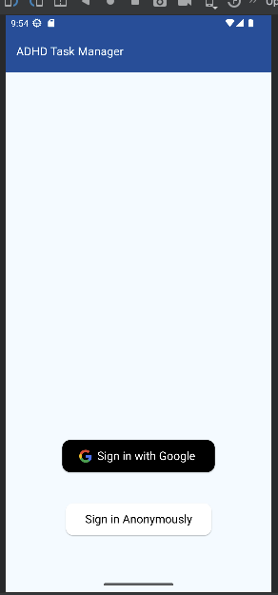

* User can sign in using either of the two options.
* Signing in with Google does not work on the emulator.
* The fonts and background make it easy to read what is on the screen.
* Screen is not cluttered nor distracting.

1. Page after signing in (Follow Left to Right in each row)

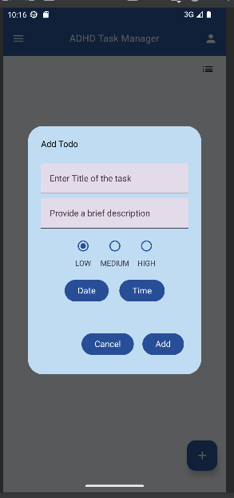

* tapping *+*  *(B)* allows users to create a task.
* Clicking anywhere on the grey area clears the options.
* The icons are mostly self-explanatory.
* Hints provided so users know what to enter in the text fields.

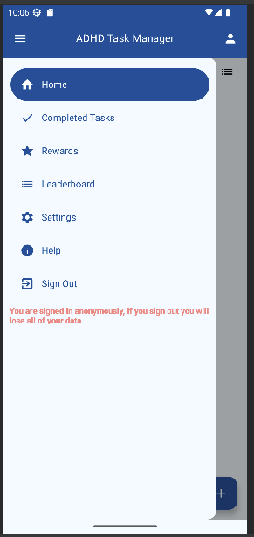

* tapping *A* gives the above options.
* Clicking anywhere on the grey area clears the options.
* The icons are mostly self-explanatory.

*A*

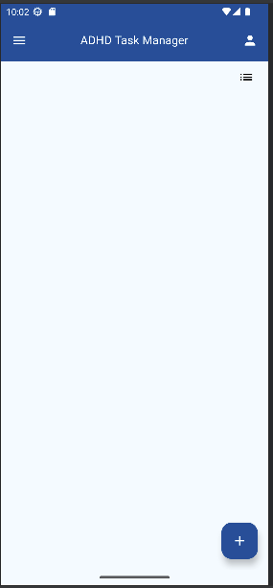

*B*

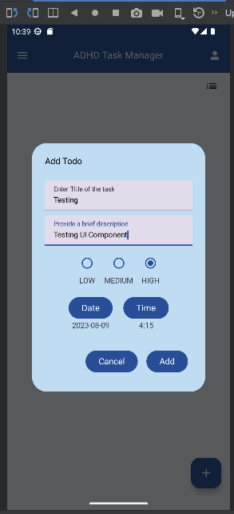 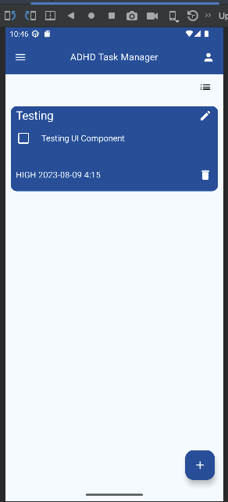

* Sample task created
* When *Add* is tapped, the task appears on the screen with three familiar icons:
  + checkbox to mask as completed.
  + Edit the task
  + delete the task

 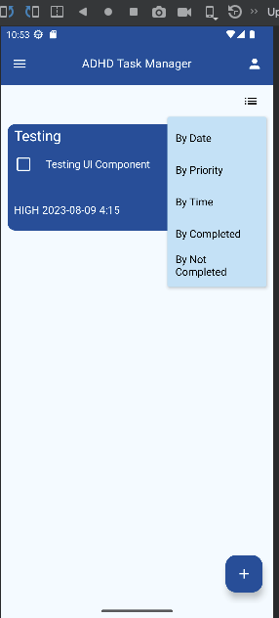

* Clicking on *C* allows user to view tasks by selected criteria

*C*

1. Completed Task page

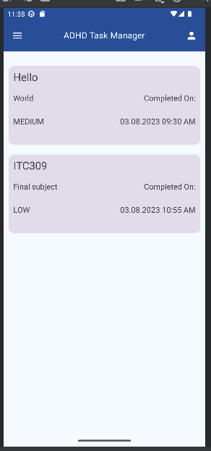

* each completed task card is separate with contrasting colours with respect to the background.
* Clicking *D* will allow user to rechoose.

*D*

1. Other pages have been designed in a similar fashion with easy navigation and ease of use in mind.
   * the ADHD Task Manager banner appears on all screens to show the name of the app.
2. When a user signs in anonymously, their work, such as tasks created remains on the app if they do not sign out, but instead just close the app.

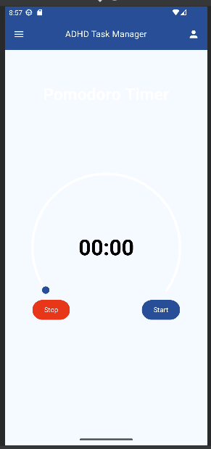 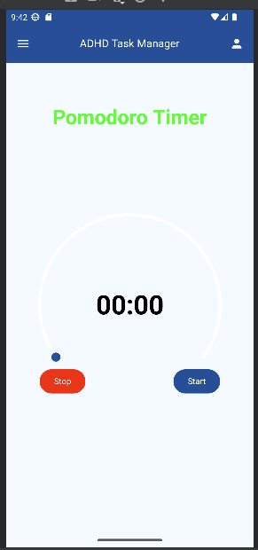

1. Pomodoro Timer
   * font colour blends with the background.
   * changed the font colour.
2. Settings page